**Quick PC**

*PC Building Assistance Mobile Application*



**Developer Guide Documentation**

CECS 491A T/TH 12:30 PM

# **Table of Contents**

**Table of Contents** **1**

**Project Overview** **2**

**Project Components** **3**

**Project Documentation Resources** **4**

Project Features Documentation 4

Requirement Specification Documentation 4

Project Design Documentation 4

**Setting Up Project Tools** **5**

Android Studio 5

Firebase 5

Github 5

**Contributing to Project Development** **6**

Developer Process 6

**Developer Support** **7**

# 

# 

# 

# 

# 

# 

# **Project Overview**

Quick PC is a mobile application written in Dart using Flutter. The application is designed to help users compare prices and compatibility of PC components. Our app can recommend parts based on the user’s budget and consider what they want to use the PC for. The app can also compare prices from different retailers to find the best deal for users looking for parts.

Due to the covid pandemic, many people have gained interests in building a computer from scratch. Our mobile application intends to assist people in learning the different types of PC components and their respective prices through the use of our mobile application. No such applications are widely available for mobile devices at the moment and the best version of this type of software is typically in the form of a mobile website which is unintuitive to use.

Quick PC will start up asking the user to login to their already registered account or register for a newly made account. Once a user has signed into their account they will arrive at the home screen which is the launch screen. This main page acts as the entry point into our application.

This screen features a guide on how to assemble a PC, a page on what each part of a PC does, performance comparison on certain parts, a search bar for looking up parts, a system builder, and the ability to browse by parts.

The end goal of Quick PC is to give users an accessible and informative way to build and assemble a computer that fits their needs. The app can act as a gateway to learning about PC components and understanding the functions of each part.

# **Project Components**

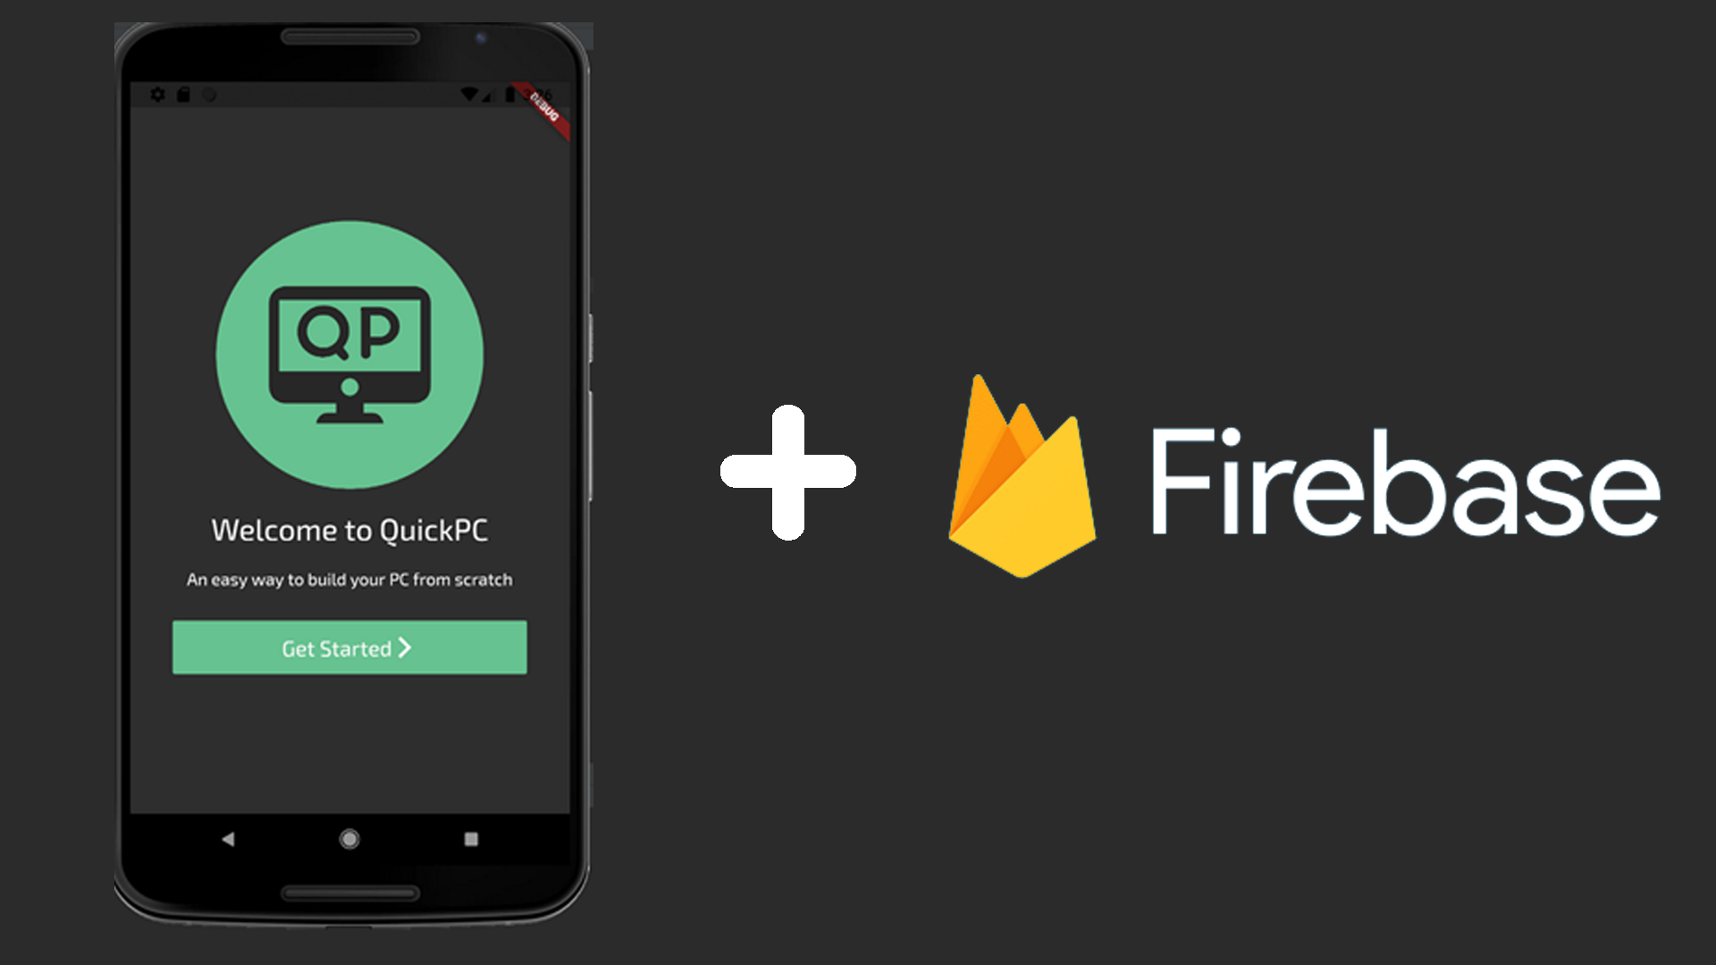

|  |  |
| --- | --- |
| **Android Studio · Flutter**  **(Mobile Application)** | **Firebase**  **(Cloud Database)** |
| QuickPC is the mobile application that supports all the features and functionality that users can interact with on their phones. Database information such as PC parts and user account data will be retrieved from a cloud Firebase. | All user data and PC part information is stored in our Firebase. User information contains data such as login credentials, and PC lists. PC part information is all the parts that can be searched for on the application. |

# 

# **Project Documentation Resources**

Project documentation resources consist of links to all our documentation that outlines the scope, features, and design of our QuickPC application.

## Project Features Documentation

Project feature documentation outlines the goals and features of Quick PC.

Link: [Project Features Documentation](https://docs.google.com/document/d/1EoFKImzWpB6J7FoF_JEkOmh5kWsxdp8raP5_IXPPX3Y/edit?usp=sharing)

## Requirement Specification Documentation

Requirement specification documentation outlines the stakeholder model, goal model, system vision, usage models, use cases, and functional & nonfunctional requirement of QuickPC.

Link: [Requirements Documentation](https://docs.google.com/document/d/1oKcBbFID_hBPgmNbVm4_TRsCYWt95lrHQdAVzyNaOXs/edit?usp=sharing)

## Project Design Documentation

Project design documentation outlines the behavior and architecture specification of QuickPC.

Link: [Design Specification Documentation](https://docs.google.com/document/d/14sPfzk_Cg3h3EAWUJA_BjiV7uG7tEHJB_EwjJmB1V0U/edit?usp=sharing)

## 

# **Setting Up Project Tools**

## Android Studio

1. Download the most recent version of Android Studio for your development platform:
   1. Download link: <https://developer.android.com/studio#downloads>
2. Execute the installer program and choose your preferred setup preferences.
   1. Installation instructions: <https://developer.android.com/studio/install>
3. Download and install Flutter SDK: <https://flutter.dev/docs/get-started/install>
   1. Add Flutter to the PATH environment variable
   2. Run Flutter Doctor
4. Install Dart and Flutter plugins for Android Studio
   1. In Android Studio
      1. *File > Settings > Plugins > “Dart/Flutter” in Search > Install*
5. Integrate Google Firebase into Android Studio Project

## Firebase

1. Create a Firebase account using your Google account
   1. <https://firebase.google.com/>
2. Join a project or create a new project on Firebase
   1. <https://console.firebase.google.com/u/0/>
3. Connect project to program through setup page
   1. <https://console.firebase.google.com/u/0/>

## Github

1. Create a GitHub account to access project files
   1. <https://github.com/>
2. Access project files through the link below:
   1. <https://github.com/gcisneros310/QuickPC>

# **Contributing to Project Development**

Developers will be able to contribute to the QuickPC application by accessing our Github repository.

Link: <https://github.com/gcisneros310/QuickPC>

## Developer Process

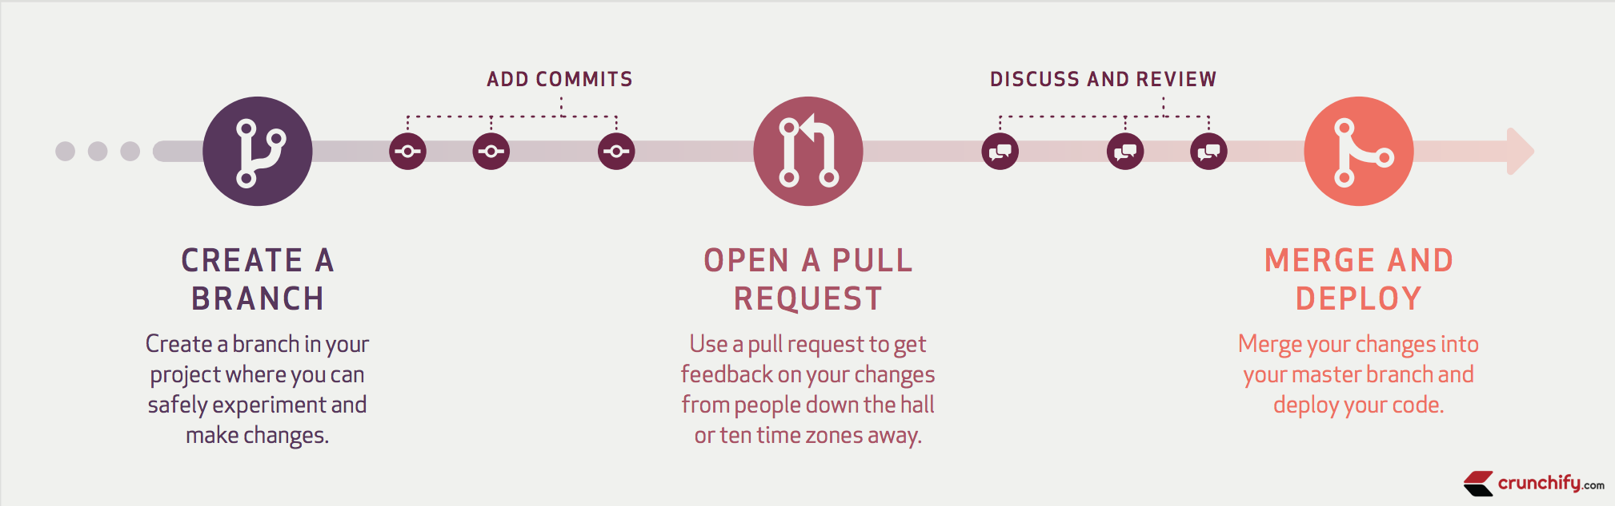

The process of developing new features for our projects involves creating a separate branch of our project to implement planned features. A new branch is made by branching off from the master branch which is our main branch with approved and reviewed features added to our project. Once we have created a new branch we develop and program the new feature we want to add to that branch. After we have added new commits to our branch, we open a pull request to collaborate and communicate about the new feature implemented in the branch. Once we have discussed the new feature we then merge the new approved feature and changes into our master branch.

# **Developer Support**

If you encounter any issues or would like to submit a feedback, please contact one of the developers listed below:

Gustavo Cisneros: [gustavo.cisneros@student.csulb.edu](mailto:gustavo.cisneros.3@gmail.com)

Anthony Dawson: [anthony.dawson@student.csulb.edu](mailto:anthony.dawson@student.csulb.edu)

Osman Khan: [osman.khan@student.csulb.edu](mailto:osman.khan@student.csulb.edu)

Jose Vasquez: [jose.vasquez01@student.csulb.edu](mailto:jose.vasquez01@student.csulb.edu)

Kevin Vu: [kevin.vu01@student.csulb.edu](mailto:kevin.vu01@student.csulb.edu)